HITEC UNIVERSITY TAXILA
Department of Computer Science
BS Computer Science Program
4st Semester, Session-2023 Section C
Lab Final-Term Examination, Spring 2025
Subject: | CS-302L Artificial Intelligence Lab | Date: | Monday, April 4, 2025
Marks: | 25 | Time: | 60 Minutes
Name: |  | Reg. No.:

GENERAL INSTRUCTIONS:
- Usage of Mobile phones is strictly prohibited.
- Communication of any kind is strictly prohibited.
- Transfer of data in any form is not permitted.
- Read each question carefully and follow the instructions.

Task #1 | [CO-4 – P4] [SO–5] | (Marks: 10)
Construct the Uniform Cost Search/depth-limited search algorithm (depth limit = 2) for the graph below.
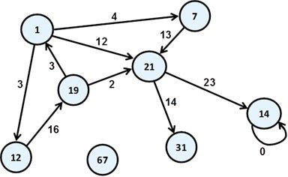
Node | h(n)
1 | 25
7 | 20
12 | 35
14 | 5
19 | 15
21 | 18
31 | 10
67 | 50
0 | 0

Task #2 | [CO-4 – P4] [SO–5] | (Marks: 15)
Construct a K-means cluster model for the data below. K=2. Show the final clusters and their centers. Also, check the model by giving new inputs, also show with the help of visualization from which cluster your new input belongs.
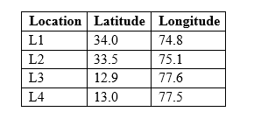
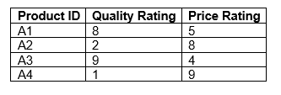

HITEC UNIVERSITY TAXILA
Department of Computer Science
BS Computer Science Program
4st Semester, Session-2023 Section D
Lab Final-Term Examination, Spring 2025
Subject: | CS-302L Artificial Intelligence Lab | Date: | Tuesday, April 3, 2025
Marks: | 25 | Time: | 60 Minutes
Name: |  | Reg. No.:

GENERAL INSTRUCTIONS:
- Usage of Mobile phones is strictly prohibited.
- Communication of any kind is strictly prohibited.
- Transfer of data in any form is not permitted.
- Read each question carefully and follow the instructions.

Task #1 | [CO-4 – P4] [SO–5] | (Marks: 10)
Construct Breath First Search/ Depth First Search on the graph below.
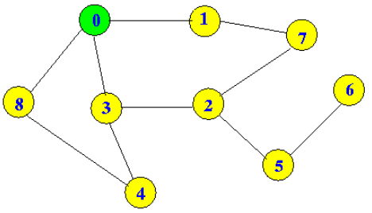
Task #2 | [CO-4 – P4] [SO–5] | (Marks: 15)
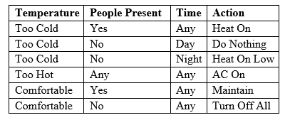
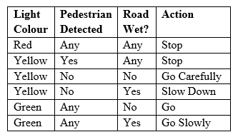
Construct a simple reflex agent on the data below.

